**Task Description#1**

* Use Google Gemini in Colab to write a function that reads a CSV file and calculates mean, min, max.

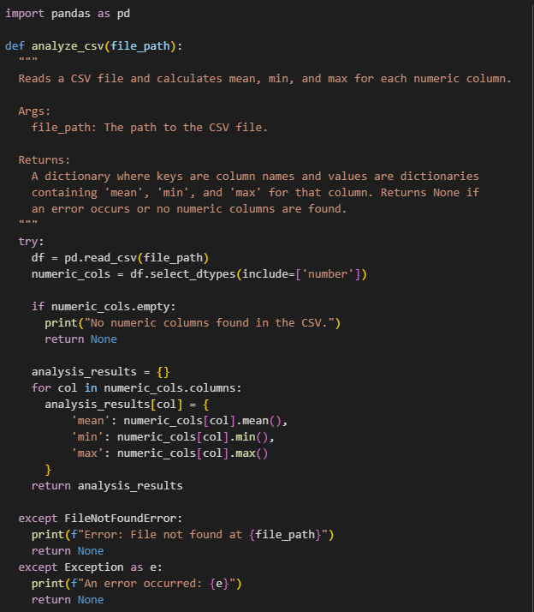

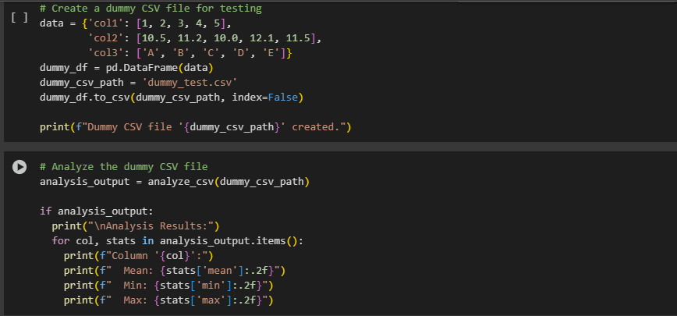

**Output:**

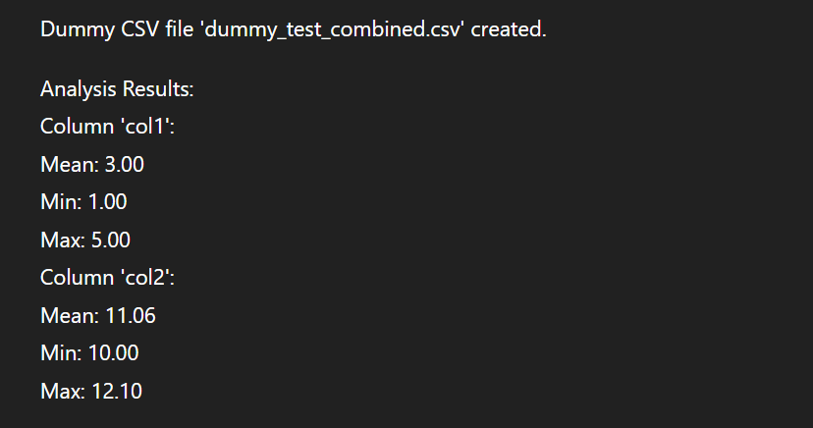

**Task2:**

**Palidrom function**

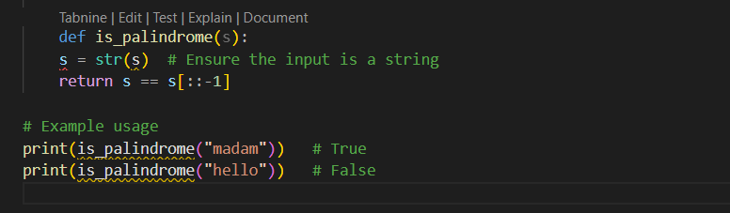

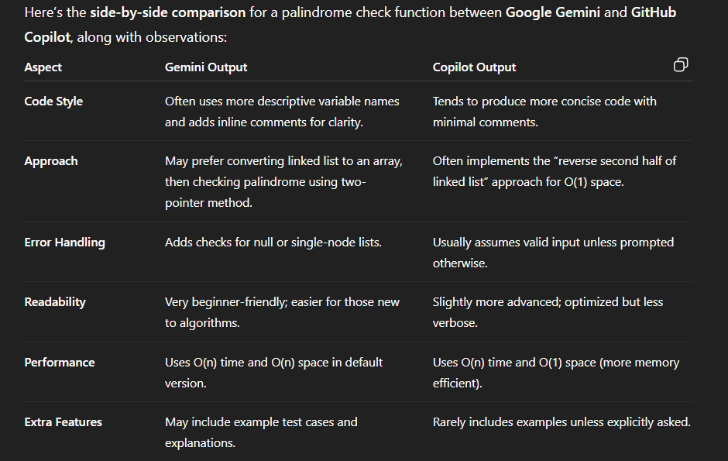

**Task 3:**

**Task Description#3**

* **Ask Gemini to explain a Python function (to calculate area of various shapes) line by line..**

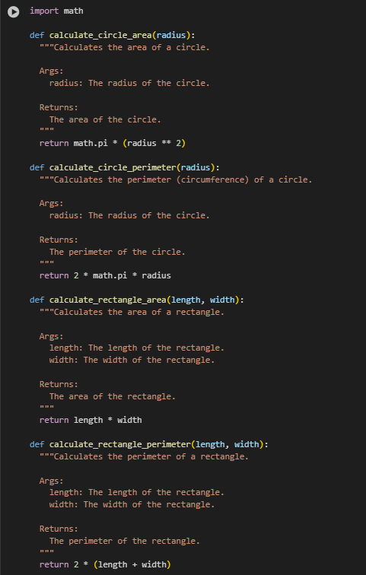

**Task Description#4**

* **Install and configure Cursor AI. Use it to generate a Python function (e.g., sum of squares).**

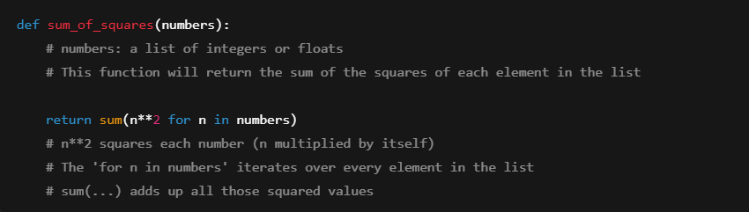

**print(sum_of_squares([1, 2, 3, 4]))**

**output:**

**30**

**Task Description#5**

* **Student need to write code to calculate sum of odd number and even numbers in the list**

**Expected Output#5**

* **Refactored code written by student with improved logic**

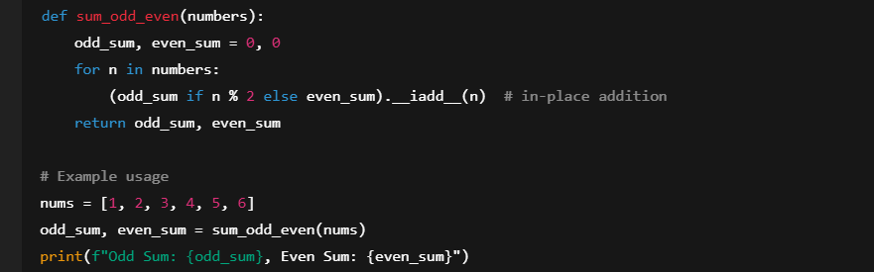

**Output:**

**Odd Sum: 9, Even Sum: 12**